Bogova - Where Bog Is God
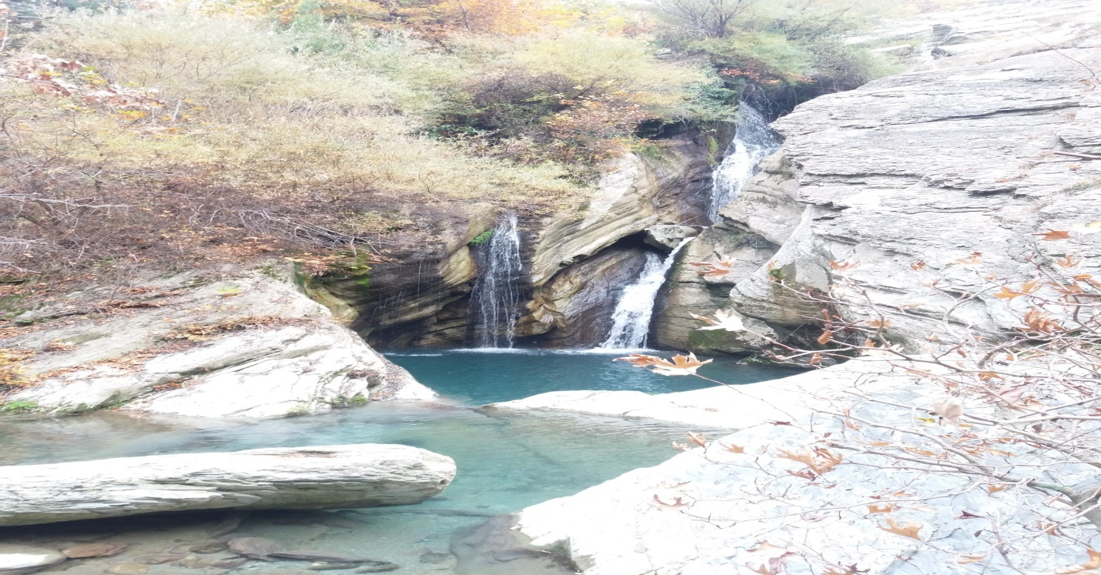
Background
Synonymous with heaven, Bogova village is a popular draw because of its magical waterfall, which is famous as the "Sleeping Pearl" under Tomorri Mountain. Spend a memorable time in this XIII century settlement and see the miracle of nature as hundreds of streams come out from the mountains. This place is home to endless type of trees, plants and animals.
Itinerary
- We start early from Berat for a short and scenic drive to Bogova that takes us through the Osumi Valley vineyards, hills and mountains.
- Stop in Bogova village for coffee or raki, the traditional Albanian alcoholic drink prepared with grapes and other fruits.
- Hike to the waterfall, a short and lovely walk over small wooden bridges with views of the beautiful streams that come from the waterfall and also Bogova Park.
- Visit the magical waterfall, and if you wish, you can swim or jump from the high rocks straight into the water.
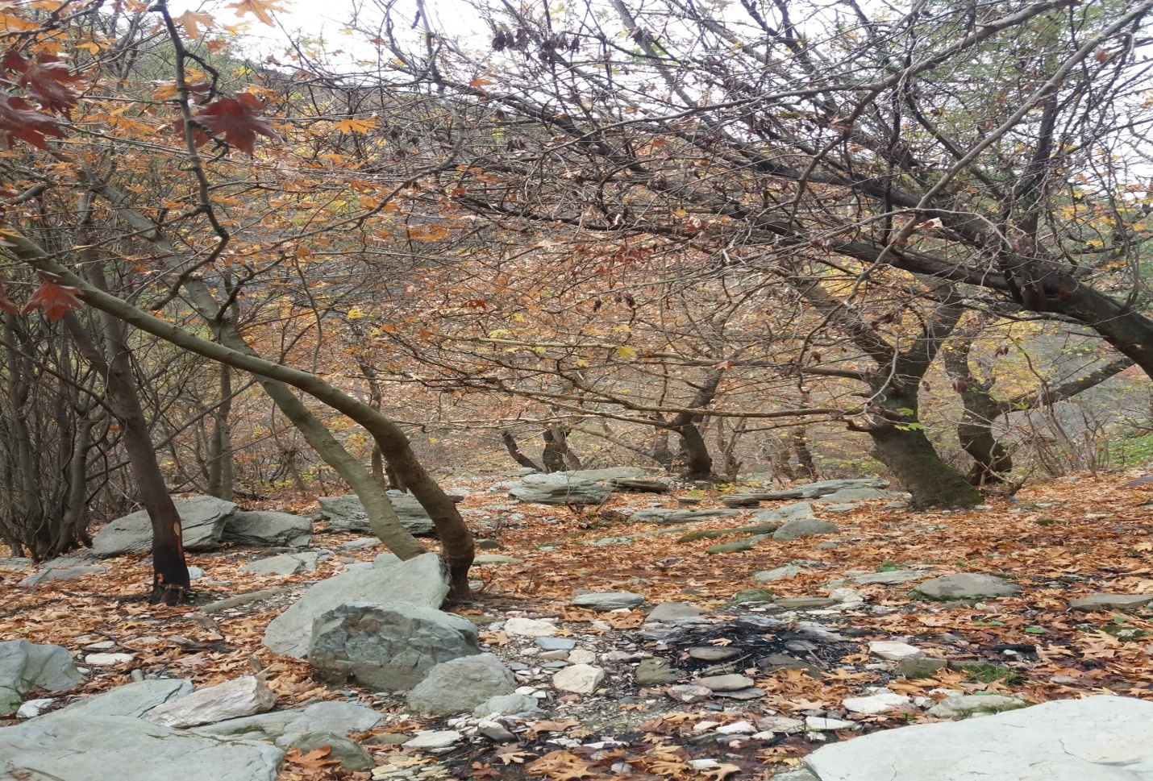
Pricing
30 Euros for 2-4 people, 22 Euros for 5-10 people

What's Included?
- English tour guide
- Picnic lunch (water, sandwich, fruits)
- Park entrance fee
- Transport as per Itinerary
What's Extra?
- Coffee or drinks during breaks.

Additional Information
- What to bring: comfortable clothes, hiking shoes, swimsuit, a hat, sunglasses and camera.
- Prices are flexible
- If you have your own transport, the price is lower.
- For groups with more than 5 participants, the price is lower.
- Let us know if you have any special requests or needs!

