Cheers to Albanian Wine!
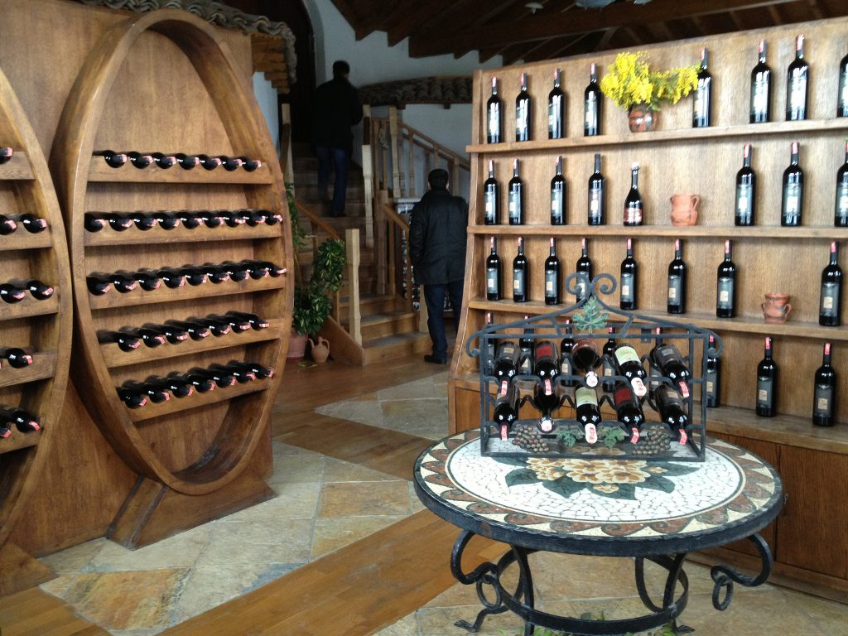
Background
On this tour we will explore one of the oldest and best wine producing regions in Albania and learn the history of Berat, which started producing wines in the 8th century BC. Meet the families who started growing grapes in their own gardens and backyards so they could create rakia and wine for personal consumption.
We are proud that one of five indigenous grapes is from Berat, Puls/Pules. Though originally used to make rakia (a traditional fruit brandy popular in Albania), this grape now yields some of the finest dry white wines in the country. With its delicate floral bouquet and long finish, this could be a worthy addition to your wine cellar.
Itinerary
1. Nurellari Winery - Famous for Montemeca
- Located in the South of Berat near Osumi valley, we are going to explore the vineyard and meet Fatos, the man who spent his life producing wine.
- View of river and valley is unique. We'll try some Albanian snacks and "Montemeca," a dry red wine made of three types of grapes: Montelupciano, Merlot and Cabernet. For 2011 this was the best wine in Albania!
2. Roshnik Village and Alpeta Winery
- This is the place where the famous "Puls" has been cultivated for a thousand years, even before Alpeta was a famous winery. For them, this grape is not just a grape but is part of their identity. The village itself is magical and is surrounded by hills, lakes, valleys and vineyards. From here we have a full panorama of Tomorri Mountain
- Let us try Puls in the place of Puls! After the wine tasting, we will have lunch prepared with local products. When we say local, they are really are native to this area and the secrets are not shared with any other villages! The restaurant itself is rustic and will give you the feeling of life a century ago.
- After lunch we will visit a historic house where six grand viziers of the Ottoman empire came from. We'll walk around the village after lunch and get ready to go on the best Albanian Winery:
3. Cobo Winery - Famous for Kashmer & The Red of Berat
- Why Kashmer? Because it combines the classical triple Cabernet, Shesh and Merlot; the Red of Berat is inspired by the red colour invented by our famous artist, Onufri.
- Shesh I Bardhe or Shesh I Zi are indigenous Albanian grapes that come in two kinds - White or Red White wine.
- And don't forget: Albanian wines are 13% vol. so please drink carefully! This is the last stop. After Cobo Winery, we head back to your hotel or your destination
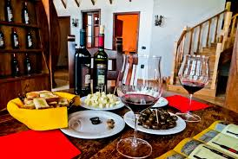

Pricing

90 Euros for 2-4 people, 80 Euros for 5-10 people

What's Included:
- Transportation as per itinerary
- English tour guide
- Wine degustation at: Cobo winery, Nurellari Winery, Alpeta Winery
- Lunch in Roshnik at traditional restaurant
- Entrance fee for: Castle of Berat, Onufri Museum, Medieval Centre

What's Extra?
- Bottles of wines and other local products you wish to buy

Additional Information
- Prices are flexible
- If you have your own transport prices are lower
- This could be a tailor-made tour
- Please let us know if you have any other questions!

