Cultural & Historical Tour of Berat
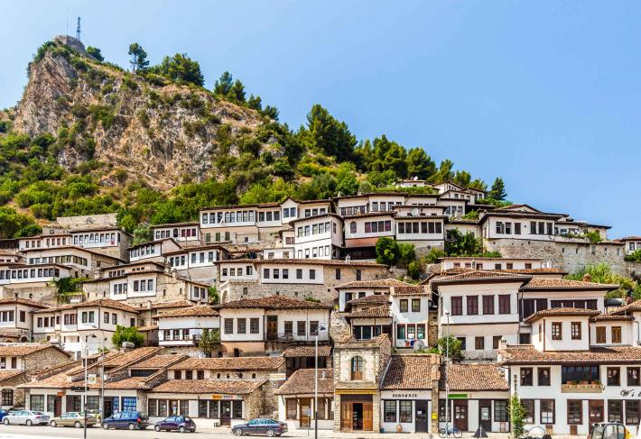
Background
This two-day tour will introduce you to the cultural and natural beauty of Berat and its surroundings. Visit the ancient castle, old communist buildings, and the neighbourhoods of Mangalem and Gorica on the first day. The next day will be spent visiting canyons, waterfalls and small intriguing villages and towns outside of the city.
Itinerary
Day 1: Berat Highlights & Wine Tasting at Night
- We will start with the castle of Berat, one of the oldest in the Balkans, built on a 178m hill where you can enjoy the view of mountains, valleys, and rivers. There are about 400 old houses from the 17th century and more than 20 churches from the 13th century. Old Illyrian walls, Byzantine churches and two mosques make the visit more interesting.
- Visit the Iconography museum named to honour Onufri, an Albanian painter of the 16th century. Onufri was a master of Icons and frescos and he is famous because he depicted the great revolution through his paintings. He created a mysterious red color and even the scientists do not know how he created it.
- After a 2 hour visit to the castle, you will have free time to explore narrow cobbled paths and carvings from wood and stone, made by locals.
- The next part of day will be spent in downtown Mangalem or as it is known, "The City of a Thousand Windows." With a unique type of construction, we will walk through the neighborhood inhabited by crafters; about 500 families of craftsmen used to live here.
- Visit St Michael church, a sacred place for Christians built in the 13th century with perfect Byzantine architecture. Visit the Bachelor Mosque-why is it called this? We will find out on this tour!
- After Mangalem we will go to Gorica, the other old part of town, built during the 17th century. It was inhabited mostly by people of southern Albania.
- Walk over Gorica Bridge, the biggest one in Albania that was constructed in 1777. Kurt Pasha, the Pasha of Berat, built it and it is still well preserved.
- There are endless monuments in Berat to visit. We will visit the King Mosque built by sultan Bajazit in 1490.Just a few meters from there is Helveti Teqe built during 1500 and rebuilt later by Kurt Pasha during 1722. It's a unique monument in Albania: its ceiling is decorated with 24 karat gold.
- If you are not tired in the late afternoon, you can enjoy wine tasting. Berat is famous for wines. We have our indigenous white wine called The White of Berat or Pulsi I Beratit. We will go on a wine tour to explore the vineyard and the process used by locals to produce it. We can try some Albanian snacks here as well.
- Take a breather now and relax. Back to hotel
- Tomorrow it will be a long and unforgettable day!
Day 2- Canyons, Waterfalls and Old Communist Buildings
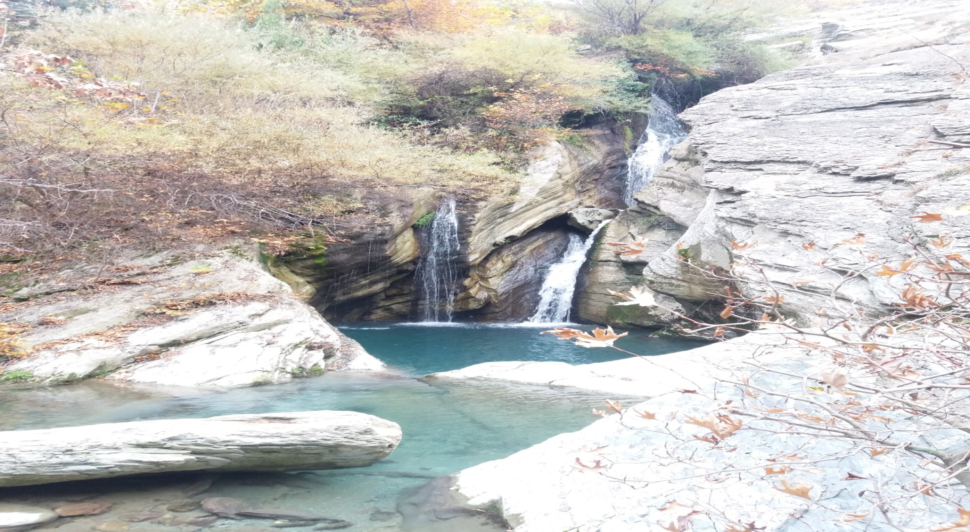
- We will start early in morning since there will be many things to do. It will be a nice drive with stunning views of river, valley, old houses and mountains.
- After a 1-hour drive from Berat, we will stop in Bogova, a special village famous for its picturesque views of nature, its national park, freshwater, mountains and big trees.
- We will start an easy hike to reach the hidden Bogova Waterfall. The fresh water of the river which is created by the waterfall will follow us all the way. We will be "disturbed" by the voice of river, sounds of birds and wind. The weather will be cool and pleasant.
- After an easy 30-minute hike, we are in Bogova. The hidden waterfall will be music to the soul. Brave tourists can jump and swim in the cool, clean water.
- Drive to Polican, a town founded with the purpose of creating guns. During communist times it was the most secure place in Albania. Nowadays it seems like a ghost town though the taste of the past is still there. Old gun factories, sophisticated bunkers and tunnels built to protect the important persons of the Communist government are still here.
- After experiencing the communist era, we will move to Osumi Canyons, known as Colorado of Albania. It's about 15 km long and the highest part of canyon is about 78 m. Created millions of years ago, it gives a special feeling with the Osumi river going through and there are different kind of trees and birds and places to swim or take photos.
- We will take a short break to explore a bit and after admiring the beauty we'll go on an adventure trek to explore the canyon, crossing the river several times. After 1 hour, we will stop since it's impossible to walk. If you are brave enough, you are invited to cross to the other part by swimming!
- We will learn about two legends: one about Abaz Ali, a fighter and the cousin of prophet Mohammed, whose soul locals believe has come to rest for eternity here in our land. The followers call themselves Bektashi, the twelfth Islam branch (and the biggest in Albania, with its headquarters is Tirana.) The other legend is a secret that will be disclosed to you when we are at the canyon!
- Back to Berat
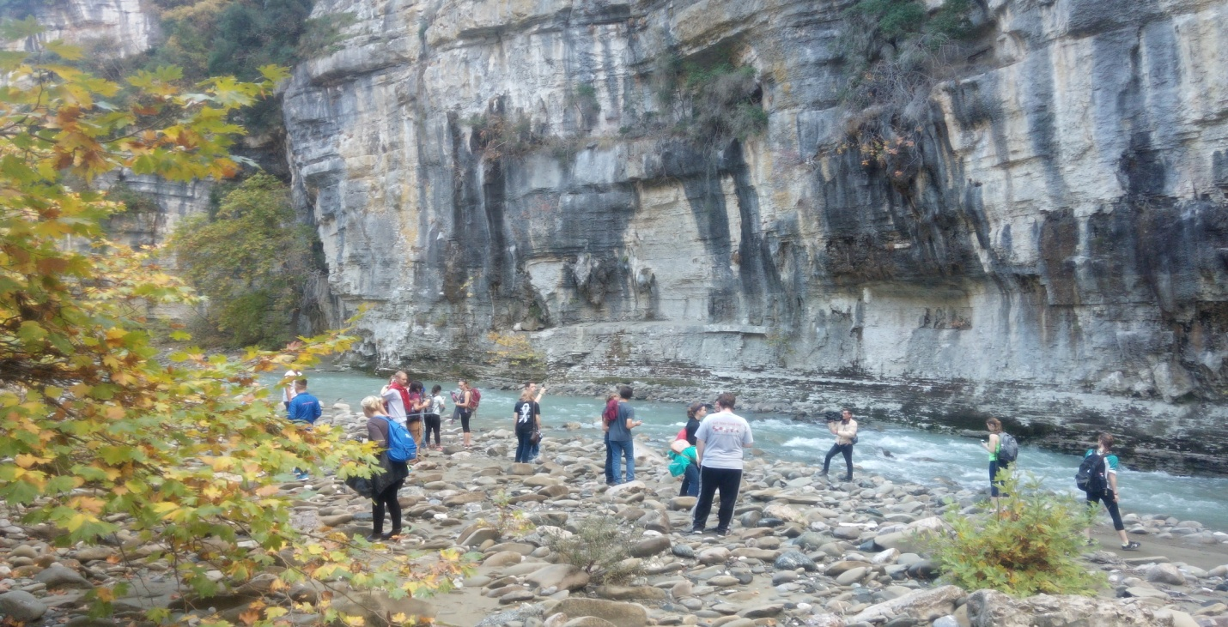
Pricing
101 Euros for 2-4 people, 85 Euros for 5+ people
What's Included:
- Breakfast and lunch for 1st and 2nd day
- 1 night in guest Houses or 3-star hotel
- Transport as per itinerary
- Tour guide as per itinerary
- Entrance fee for all monuments, churches, museums and mosques
- Wine tasting
- Return transfer from Berat to canyon
What's Extra?
- Transfer from Tirana to Berat Dinner on 1st and 2nd day
- Drinks during lunch
Additional Info
- For the second day you will need: hiking shoes, comfortable hiking attire, hat, sun glasses, bottled water, swim suit, towel
- Prices are flexible: for groups with 5 persons and more, prices will be lower
- If you are already in Berat at a hotel, prices will be lower
- Tour can change depend on client's wishes
- Please contact us for any further information!

