Eat, Drink and Lodge with an Albanian
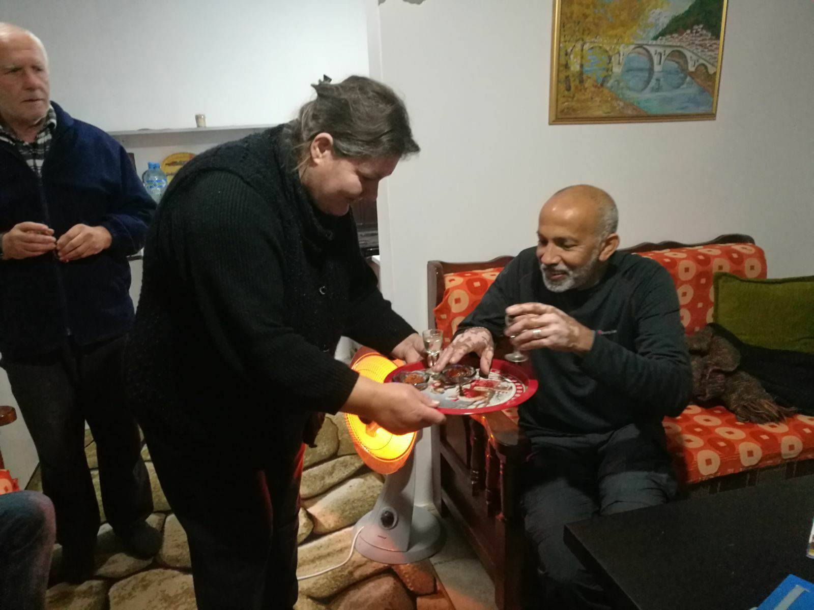
Background
Do you want to feel like an Albanian? If yes, then let’s stay in a local house! We will enjoy their hospitality and help them prepare our dinner. They will be happy to teach us some of their traditional dishes. We will see their daily life, understand Albanian traditions and learn about the history, legends and architecture of the place.
Itinerary
Day 1 – Live Like a Local in Berat
- The perfect place to start is Berat Castle, 2400 years old and still home to these people (since the 4th century BC, the place has never been vacated!)
- Meet Nina, Fredi and their son Arjan.
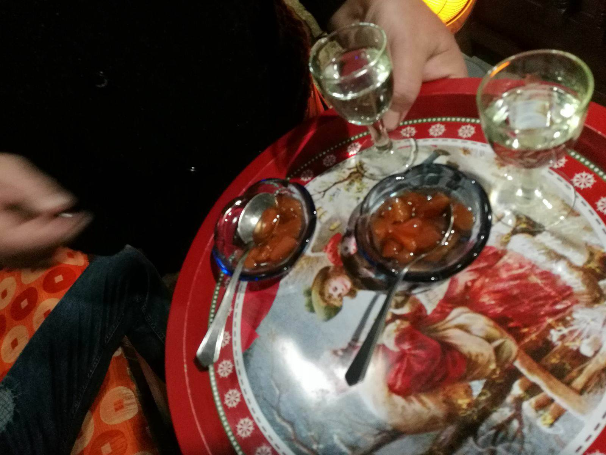
- They are a traditional Albanian family living inside of Berat Castle. Their house was built during the XVII century and they are trying to keep it as it was without making any changes. Fredi is a master in building furniture and Arjan is following in the steps of his father.
- We will have a little bit of coffee and a glass of raki to warm up. After reading the future in the Turkish coffee cup, you will understand how it feels to be a guest of a traditional Berat family. They are warm and kind and although they only know a few words in English and Italian, you can understand their smile and what they want to tell.
- We will enjoy homemade food prepared by Nina. She is famous for her desserts made with different kind of fruits! They have a big garden in the house and from there you can see all the buildings around the castle. The uniqueness of this place will stay in your memories for a very long time.
- After lunch, you can hang out around with locals, see the old churches of XIII Century, old mosques and many other monuments along with iconography and ethnographic museums. There are more than 20 attractions inside the castle and more than 10 attractions in the old parts of town: Gorica and Mangalem
- Dinner at Baba Luka House
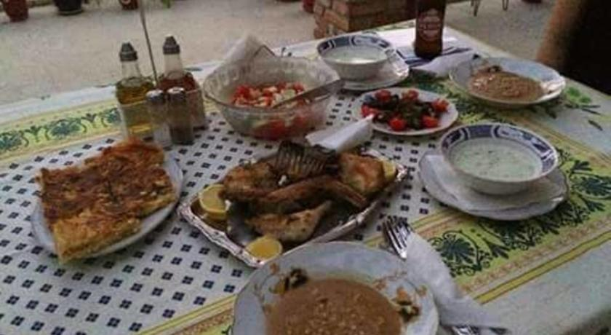
- Luka (or Luciano) is a young man living with his mother, two sons and wife. He is trying to start a family business offering accommodation and local food.
- Food will be served by his mother, a lovely elderly lady who gives love and kindness as she serves.
- After dinner on the veranda -a magical spot in Berat- we will hear some stories from Luka. Hear his stories from the revolution of 1997!
- Back to sleep in one of guest houses: either at Nina and Fredi's house or at Luka's house, depending on their availability. This is a first-time tour, equally authentic and interesting!
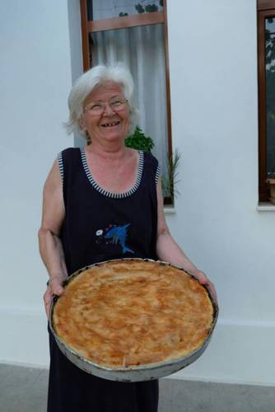

Pricing:

68 Euros for 2-4 people, 58 Euros for 5-10 people (maximum number of participants is 15)

What's Included?
- Lunch and dinner
- English tour guide as per itinerary
- Castle entrance fee
- Visit of old town
- Museum fee
- City tax
- Accommodation in one of the local homes: 2 or 3 people in twin double or triple room

What's Extra?
- Return transport from Tirana to Berat
- Local products you wish to buy from local houses

Additional Information
- If you don't want to sleep in one of the local homes, prices are lower
- For groups with 5 participants prices are lower
- If you have any other questions, please let us know!
- This could be a tailor-made tour please write to us with any suggestions

