Hiking in Tomorri Mountain

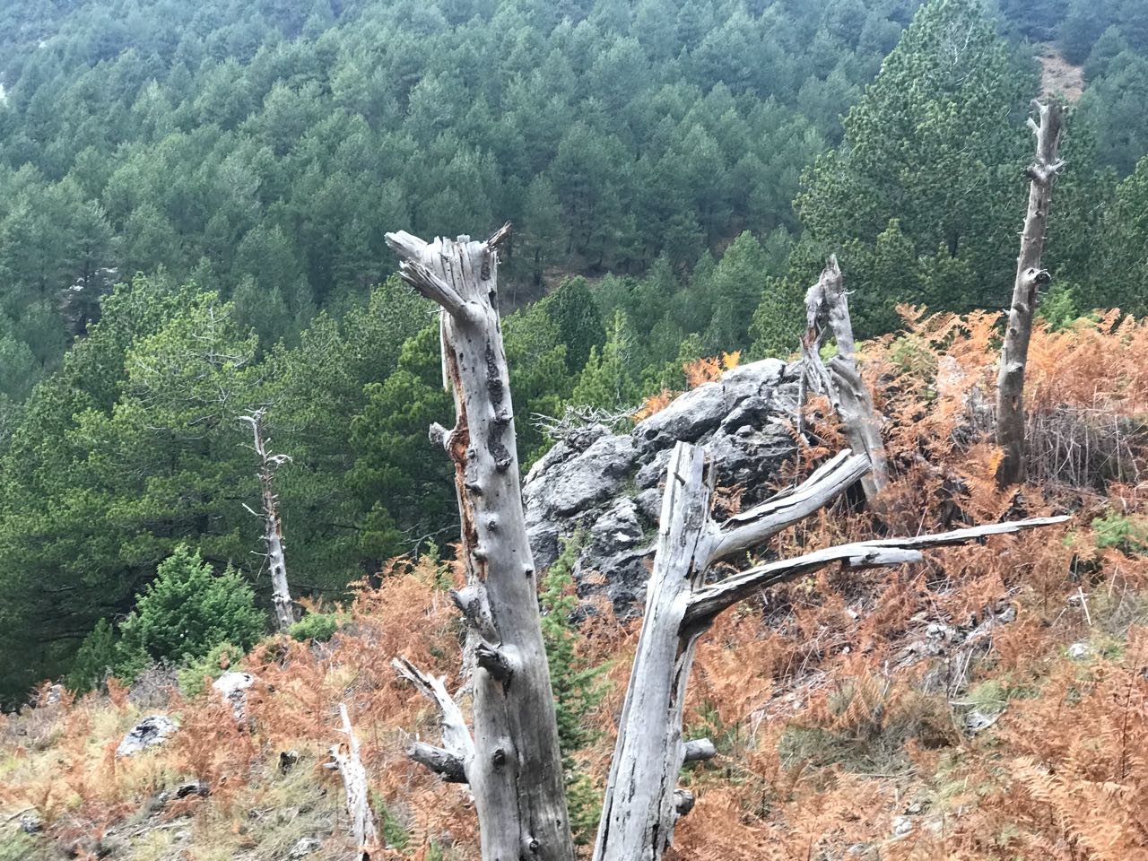

Background
This epic tour from Berat to the mountainous park will take you close to a large number of mammals such as bears, wolves and birds of prey day and night. In addition to its natural elements, the park landscape is a melting pot of recreation, history and culture. We can also meet the locals who live in the national park.
Itinerary
Day 1 – Roshnik, Dardhe and Sotira Waterfall
- Our professional local driver will come to pick you up early in Berat. Prepare for an unforgettable scenic drive from there to Roshnik.
- 10-minute break in historic Roshnik, the original home of the Köprülü family, a noble family of Albanian origin who, during the Ottoman Empire, produced six grand viziers (including Kara Mustafa Pasha, who was a stepson) and high-ranking officers. The era in which these grand viziers served is known as the "Köprülü era"; we will come back to Roshnik for a wine tasting and dinner.
- Drive from Roshnik to Dardhe; 1h30 by road (depending on conditions.) During the drive, we will be surrounded by the wilderness of the National Park.
- Arrive Dardha, a 700-year-old village, rich in tradition and history. Only five families remain here - the others migrated during communist times. This is an isolated land. The locals are lovely and they will invite us to a cup of coffee. You'll find it hard to forget their unique way of living -they're hard workers who have faced many struggles while maintaining a positive attitude. You will feel something special during this tour, as though you are on a mythical trip to the "Mountain of Good." People live in harmony with nature, animals and God. Modern life has skipped this place.
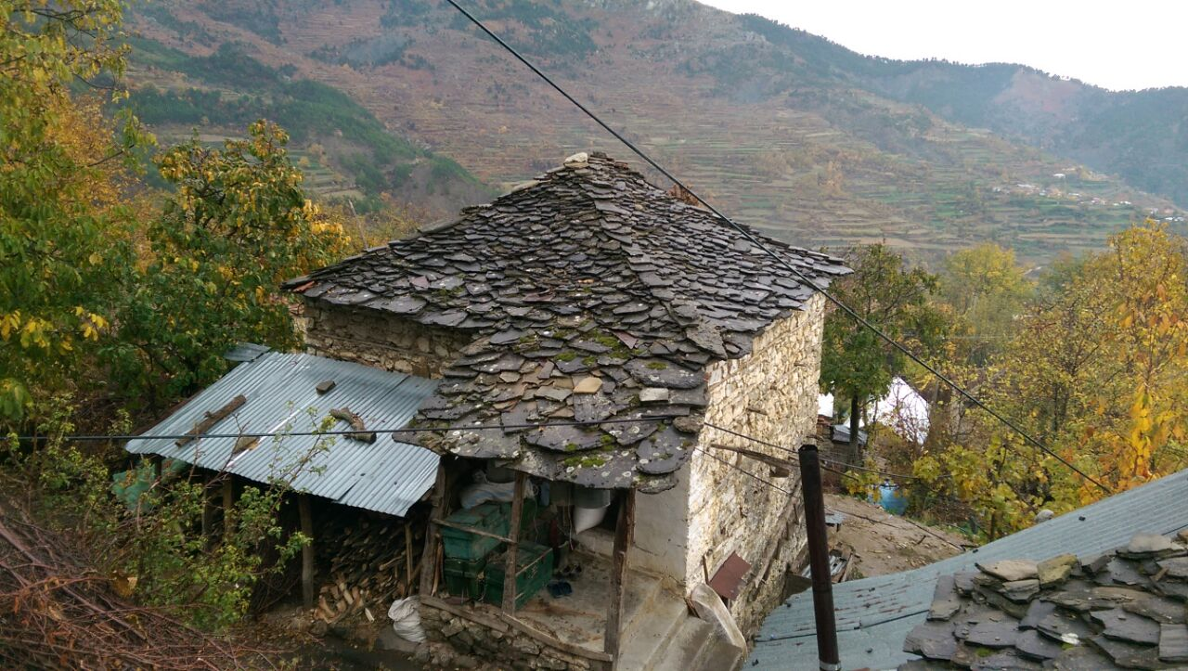
- Our local tour guide will take us on a 3-hour trek to reach one of the most beautiful waterfalls in Albania called Sotira, an easy hike with fresh air and beautiful scenery to observe. Sotira waterfall is different from the others -the water comes from a cave and nobody knows the source. Locals believe this is a gift from God to make their life better.
- Lunch at Sotira waterfall. We will explore the area, freshen up in the cold clean waters, hike around and indulge in photography.
- Head back to Roshnik for a wine degustation in a rustic winery; dinner will not be tourist fare, but the real Albanian cuisine
- If you would like, we can sleep in Dardhe village at a local house to further explore!
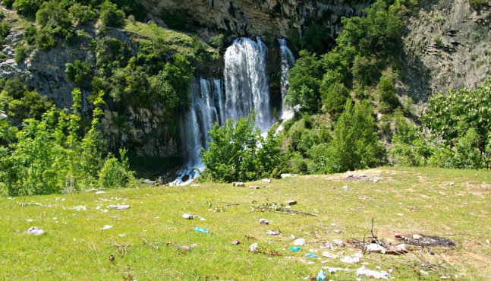
Day 2: Hike Cuka Partizan Tomorri Mountain
- We will start early in the morning and after listening to the instructions of our ranger guides, we will begin the long haul up this high mountain, with an elevation of 2417m (7930 ft) above sea level
- The trek will be unforgettable as we pass through Tomorr National Park, which is noted for its diverse species of deciduous and coniferous trees and a great variety of flora. Many endangered species are free to roam and live in this area such as bears (Ursus arctos), wolf (Canis lupus), and birds of prey.
- During our hike we will stop for short breaks on scenic places where we can enjoy views
- After 5 hour hike we reach the top, which has, since antiquity, been a destination for pilgrims – many historians believe that the tombs of Zeus or Jupiter are located here
- Picnic lunch on top
- Back on the village for a short rest and then start driving to Berat

Pricing
130 Euros for 2-4 people, 100 Euros for 5-10 people (maximum number of participants is 20)

What's Included?
- Picnic lunch, traditional dinner, wine degustation
- Professional driver as per itinerary
- 4X4 car as per itinerary
- Local tour guide, English tour guide as per itinerary

What's Extra?
- Bottles of wine
- Accommodation (+ 10 Euro in a local house if you decide to sleep there)
- Local products that you want to take with you (homemade jam, raki, herbal teas, etc.)

Additional Information
- What to bring: comfortable clothes, hiking shoes, sunglasses, mosquito repellent, a hat, water, a small backpack
- Prices are flexible. The itinerary of this tour can be changed if you want to omit or add something else. This could be a single day tour or an overnight tour (we can sleep in Roshnik or Dardhe village.)
- For groups more than five, the prices are lower. For tour operators, bloggers, journalists and everyone who is interested in tourism marketing, prices are lower.
- Please contact us for any question or special needs!
- Accomodation will be in local homes – 3 people in 1 room

