Osumi Canyon Tour - A Hiking Date with Nature
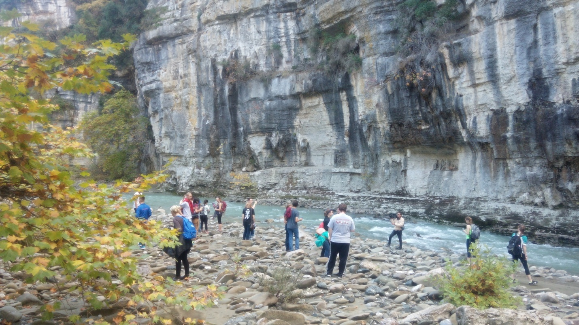
Background
On this tour we will go hiking in Albania's largest canyon, which is around 18 km long. A miracle of nature, the entire route is full of big rocks, birds of various species, old bridges, trees, bushes and popular legends about the canyons. Explore nature, walk, hike, swim and take the best of pictures!
Itinerary
- We will meet around 9 am for our drive from Berat where we will be surrounded by the beautiful landscape of Osumi Valley. Villagers here produce vegetables, trees, and many other products. After 10 km driving, we will see the vineyard of Fushe Peshtan - a village famous for wines.
- After another 30 minutes, we will stop in a city called Polican which was famous during communist times for its gun factories. During that time, millions of guns were produced and now these factories lie abandoned. You will find a lot of bunkers here, including one of the most famous ones - Enver Hoxha's. This bunker was created to defend the communists against atomic strikes from enemies.
- After this historical visit, we will continue our journey to Bogova, a village famous for natural food. Here you will find a lot of water coming out from the mountains. We can stop at a café or have some raki, otherwise we can go straight to the canyon.
- After a 2-hour drive, we will be at the canyon from which we will begin the hike – we will have to stop at some point because the water will not allow us to move further!
- Drive back to Berat, stopping for some coffee on the way
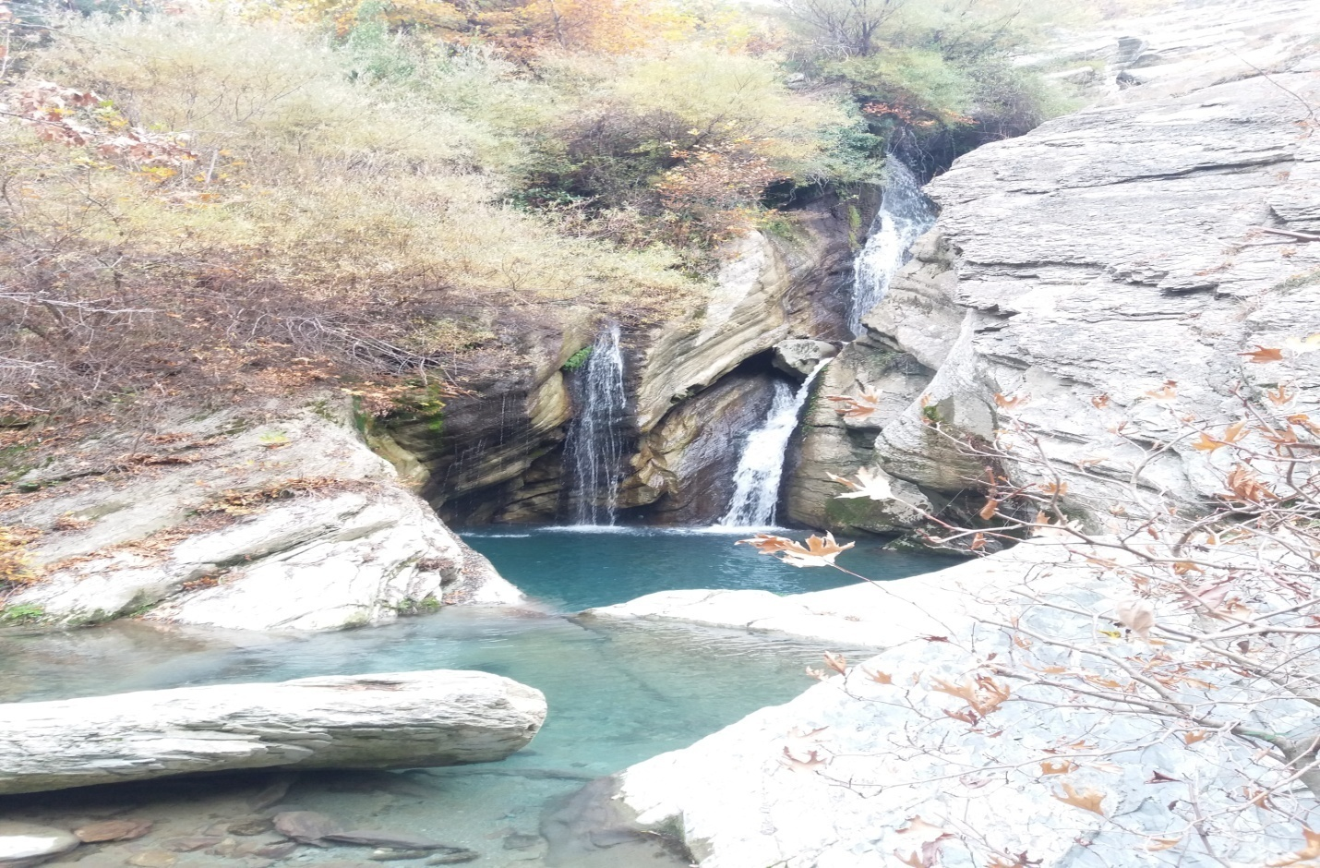

Pricing

50 Euros for 2-4 people, 40 Euros for 5-10 people

What's Included?
- Return transportation from Berat to canyon
- Tour guide
- Picnic lunch: byrek, fruits, water
- Ticket for canyon

What's Extra?
- Coffee or any other drinks/food at bars or restaurants

Additional Information
- Prices are flexible
- Price for groups more than 5 will be lower
- Price for 1 person will be higher
- Bring supportive shoes, swimwear, hats, sunglasses

