Tailor-Made Tour in Mt. Tomorri National Park
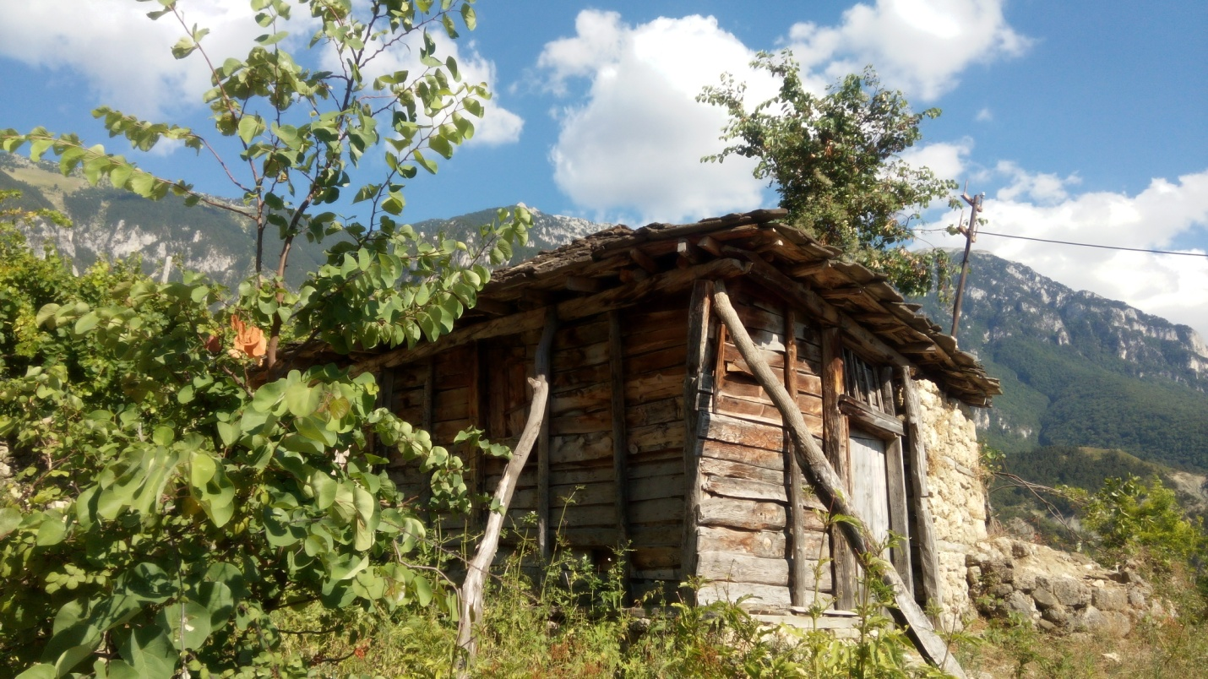
Background
This incredible tour from Berat to the mountainous park will take you close to a large number of mammals such as bears, wolves and birds of prey day and night. In addition to its natural aspects, the natural park landscape is a melting pot of recreation, history and culture. Apart from the wild, we will also meet the locals who live in the national park. 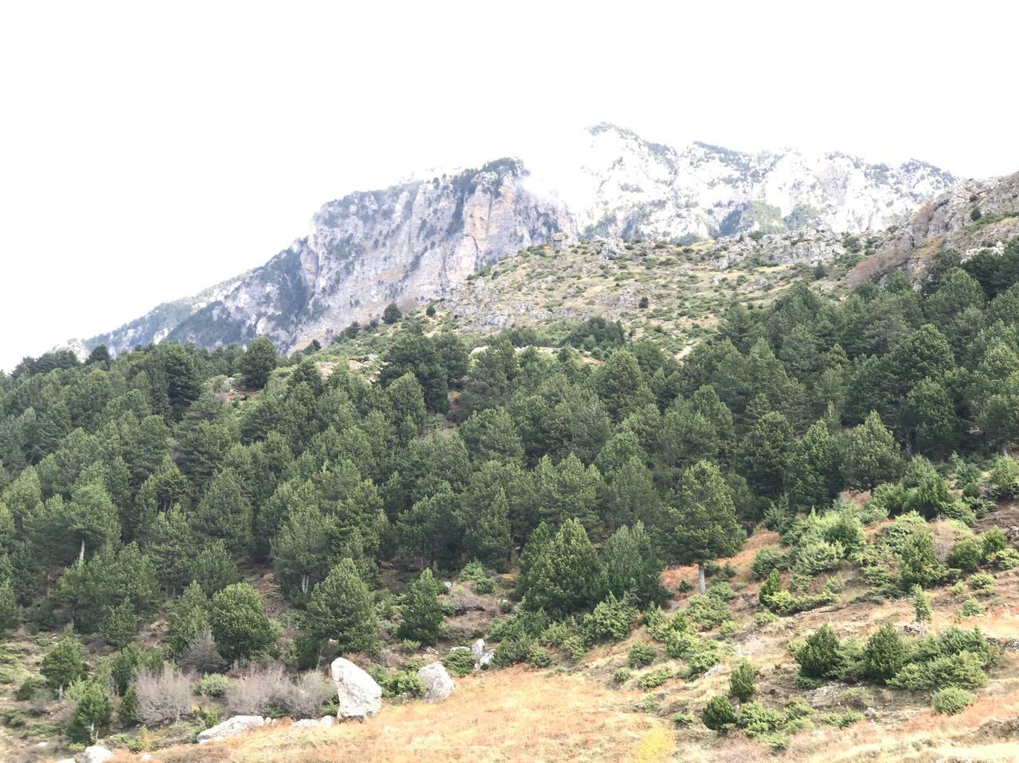
Mount Tomorr is a high mountain located in southern Albania, reaching an elevation of 2417m (7930 ft) above sea level. Tomorr is situated within the National Park, which is noted for its diverse species of deciduous and coniferous trees and a great variety of flora. Many endangered species are free to roam and live in this area such as bears (Ursus arctos), wolves (Canis lupus), and birds of prey. Mount Tomorr offers various sports such as hiking, horse or donkey riding, canoeing and skiing. Famous in Albania as the "Mountain of Gods," this is also a mythic area with many legends, ancient castles, caves and other monuments.
The Villages at a Glance
There are three unique villages more than 500 years old located on Tomorri Mountain called Lybesha, Dardhe and Tomorr. These villages are famous for their natural beauty and life here its seems like it stopped progressing centuries ago -the typical old houses are still preserved and locals keep old traditions alive, whether farming or food production. Even nowadays during the winter, cars can't get there so it remains isolated. These places are famous for their beauty, food, traditions, agriculture, history, nature and animals, but they are not famous as a tourist destination.
We are trying to sustainably work with locals to show these beautiful villages to visitors. Each area has its own character and own highlights and we can work with you to discover the best of one or them all! To make this tour even more interesting, we can sleep in one of the local's houses! Locals of this area are very kind and hospitable. We hope you understand that the inhabitants are not prepared to offer high-standard tourist services - which is exactly why this tour is so authentic! This is the normal old Albanian lifestyle. We will eat and sleep the same way the locals do.
This tour could explore one village or all three of them over three days, hiking from village to village while observing the wild nature of this area and enjoying the views of waterfalls, rivers, mountain and old houses. You can choose which ones you'd like to see – each one has something different to offer!
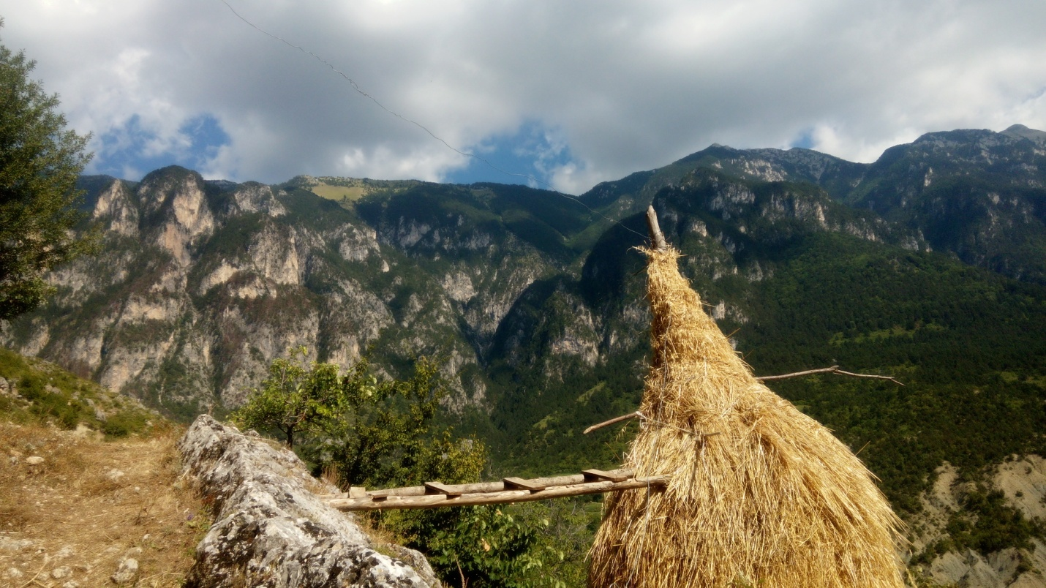
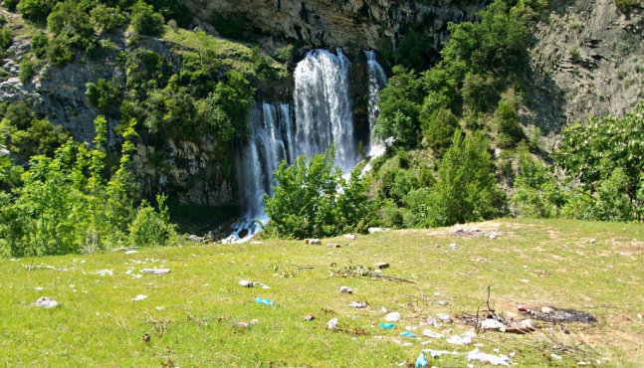
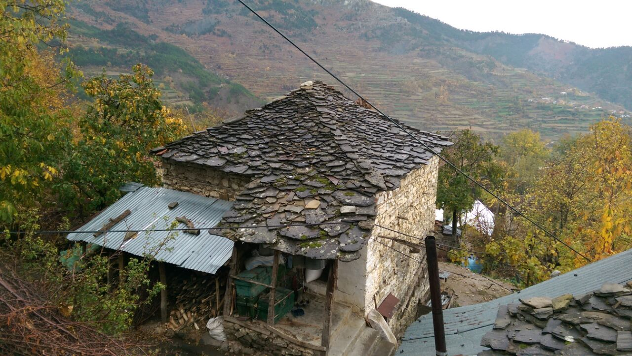
Itinerary
- We will leave from Berat to the first of our destinations, off-road in a 4x4 car.
- Upon arrival, we will have a coffee or a raki at a local family's home as a welcoming.
- From there we can partake in many activities depending on your interests: we can hike or trek different trails, all of them unique and with perfect views of the "Mountain of God," which is surrounded by trees, animals, birds, streams, big rocks and caves.
- The highest altitude we can reach is 1600m above sea level and this area is genuinely untouched by humans! Those who are brave can climb some big rocks.
- We can eat picnic lunches with traditional food in one of the alpine valleys located in this area.
- We can enlist the help of local tour guides to tell us more about the history, legends and traditions of the area.
- We can take time to learn about the flora and fauna -many endemic species exist here!
- We can incorporate photography and bird-watching.
- We can sleep in local houses with Albanian architecture - we highly recommend this because you can't beat the hospitality of the locals!
Pricing
The cost will entirely depend on what you choose for the itinerary.
The minimum price will be 65 Euros per person and the maximum price 149 Euros.
What's Included?
- Transport as required per itinerary
- English tour guide, local tour guide(s)
- Picnic lunches with traditional food, dinner in local homes as per itinerary
- Park entrance fees as per itinerary
- Accommodation in local homes as per itinerary

What's Extra?
Local products you would like to buy.

Additional Information
- You can choose only one destination or all of them
- This is an authentic tour. We are going to sleep, eat and drink in local homes. They are not trained to work on tourism. This is a rustic area with simple people offering accommodation to us. It will not be air conditioned but will have a fireplace in the room.
- To get from village to village will be at least 4 hours of hiking each day so you have to be in good physical condition.
- Please let me know if you have any questions or special needs.
- You should bring: comfortable clothes, hiking shoes, a jacket, a hat, a camera and mosquito repellent.

