5 Things You Can Do in Albania That Will Make Your Trip Special and Safe

One of the last unexplored and off the beaten track destinations in Europe, there’s never been a better time to visit beautiful Albania. Whether you’re interested in ancient history and UNESCO World Heritage sites, the more recent communist history of the country, or you simply want to disconnect and head into the great outdoors, Albania has got something for everyone!

In this post, we’ll take a look at 5 things you can do in Albania that will not only make your trip special, but safe too. We hope that it’ll help you plan out your holiday and easily make the most of your time in this incredible nation!

Learn about Albania’s communist heritage

Communism was still in force until fairly recently – 1992 to be exact! Some Albanians didn’t know that the Berlin Wall had fallen, so the fall of communism wasn’t like in the rest of the Eastern Bloc. Under the power of Enver Hoxha, the country saw some of the darkest times in its history. A social realism tour of the capital Tirana is not just a great opportunity to learn about the country’s history, but to get an alternative take on the capital too!

In such a tour, you’ll have the chance to see the Communist Memorabilia Collection at the Villa Star, old cars given to Enver Hoxha as gifts from other leaders at the New Albania Film Studio, and check out the art works in a huge anti-nuclear bunker built in the 70s. The original idea was that it’d shelter the president in a nuclear attack – now it’s just a super cool art space! Last but not least, you’ll get to visit the Block Neighbourhood – formerly out of bounds to the public!

Check out an ancient UNESCO World Heritage Site

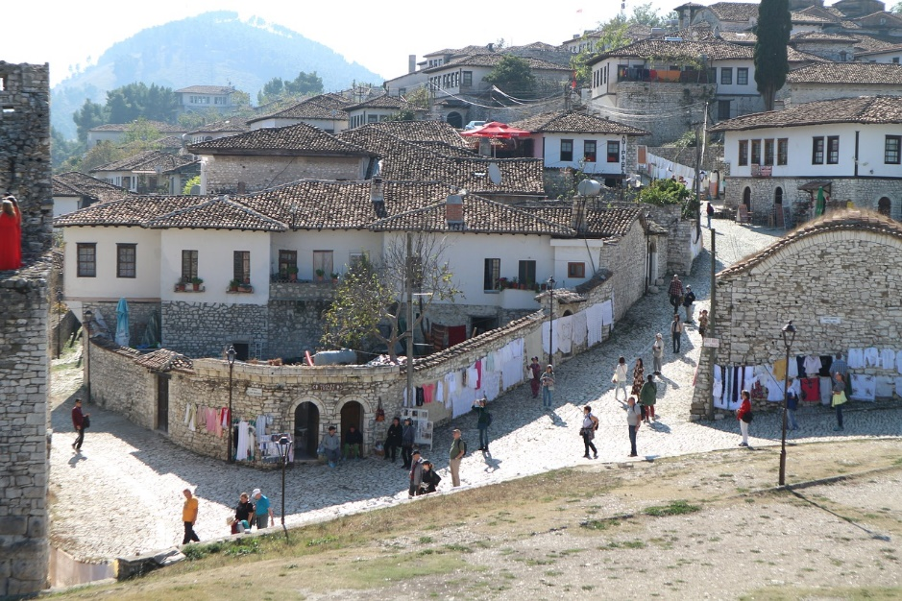
Source: https://pixabay.com/photos/albania-berat-castle-houses-3978836/

Of course, Albania’s history goes way further back than the communism era of the 20th century. Something that must be on all Albania itineraries is a visit to the ancient city of Berat, a UNESCO World Heritage site! The fortress has over 2,400 years of history, and people live in what was formerly the castle!

In more recent years, Ottoman houses, Byzantine churches, and mosques have been added to this astounding city. There’s a medieval bazaar and some world-class museums where you can learn more about this fascinating site! You can choose to visit Berat on its own or take part in several tours that will take you to this incredible city. One thing is for sure – it’s one of the most memorable things to do in Albania!

Get up close and personal with the local flora and fauna

History can be fascinating, but sometimes you’d rather just get out into nature. You may be surprised to know that the best time to get out to Albania’s great outdoors is during the winter months, when there are some incredible opportunities for birdwatching. One of the best-known parks in Albania, Karavasta, is awash with lagoons and gives excellent opportunities to see the area’s Avian life, of course with the expert help of a local ornithologist guide.

You can choose between an entire day of birdwatching, or if you’re really passionate, there’s a 6-day option too!

As well as birdwatching, there are several chances to explore the nature of this incredibly scenic country. Other opportunities for outdoor enthusiast include the Mountain with Holes near Tirana and hiking to the holy Sarisalltik Cave!

Experience the Albanian food scene and learn some of the best dishes

Have you ever tried Albanian cuisine? You might not have at this point, but once you explore Tirana’s backstreets and try the delicious authentic dishes, there’ll be no going back! Like traditional Mediterranean cuisine with a twist, Albanian cuisine has influences from Turkey, Greece, Italy, and the rest of the. Balkans in its gastronomy.

Take a tour with Albanian Tours not only to learn more about the nation’s food, but how to cook it as well. You’ll be able to head to authentic local markets before having a go at cooking some dishes yourself, with the help of mums, grandmas, and even famous local chefs!

Yes, this is your chance to sample and learn how to cook dishes such as kofte (meatballs), byrek (a pie made with filo pastry), and of course the Mediterranean staple dessert of Baklava, which needs no explaining!

Take a break on an unspoiled beach

Last but not least, something that is guaranteed to be a hit with everyone. There are few better ways to disconnect from the world than enjoying the golden sands and warm waters of the beach.

If you travel to the gorgeous Albanian Riviera outside of the high season of July and August, there’s every chance you’ll have a magnificent beach all to yourself. Of course, sharing is a problem when the beaches are this beautiful though! The larger resorts are places like Vlorë and Durrës. Not only will you have gorgeous sun, sea, and sand along Albania’s Adriatic coast here, but the best hotels and restaurants. However, if you want something a little more traditional, it’s best to head to lesser known destinations along the Riviera, where you can stay in local guesthouses and homestays!

The only downside of travelling on the Albanian Riviera is that buses can be unreliable, and you might feel that your stuck. However, with help organising your trip from Albanian Trip, you can kiss those worries goodbye and focus on having a great time!

So, now that you know the top 5 things you can do in Albania, let’s properly plan…

As Albania is still quite off the beaten track when it comes to tourism, it can be tricky to work out how to get around. Why not make things a little easier for yourself by investing in a tour? It’s a great opportunity to see everything from the list above while remaining safe and learning from local guides. Check out Albanian Trip for an unforgettable experience of one of the most underrated countries in Europe!

