The Adventure in Tomorr Village 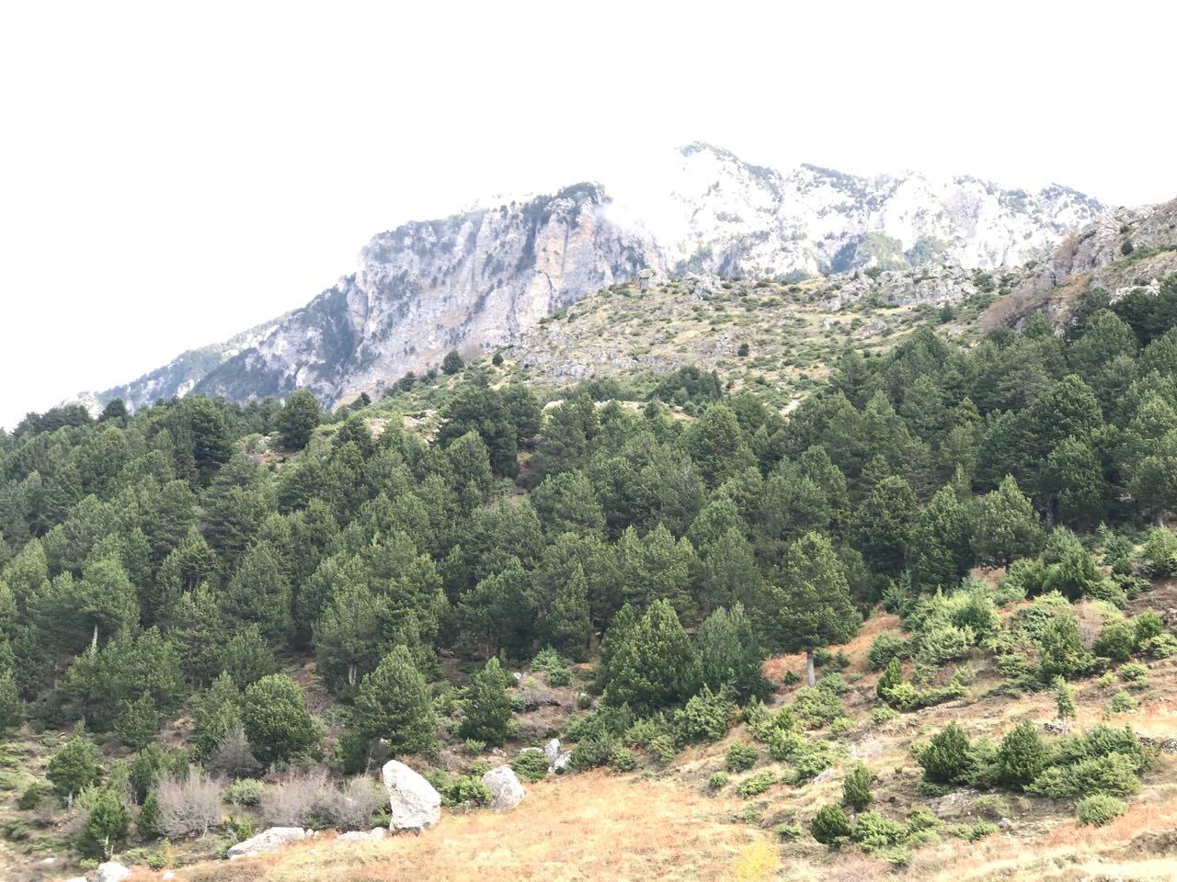

Background
This epic tour from Berat to a mountainous park will take you close to a large number of mammals such as bears, wolves and birds of prey. In addition to the natural aspects, the landscape is a melting pot of recreation, history and culture. Apart from the wild, you will also meet some locals who live in the national park.
Tomorr is a 700-year-old village located on Tomorri Mountain, about 600m above sea level. This village is famous for nature and its unique views and life here is at a pace it was 300 years ago - the typical houses are still preserved with locals keeping old traditions alive. It's an isolated village because even nowadays cars can't go there in the winter. This village is famous for its beauty, food, tradition, agriculture, history, nature and animals - but it's not famous as a tourist destination and this is precisely why we love it. We are enlisting the help of some locals to show this beautiful village to visitors. To make this tour even more interesting, we can sleep in one of the local's houses but this choice is up to you. Locals of this area are very kind and hospitable and the services offered are entirely authentic -the old Albanian lifestyle is preserved in which we will eat what they eat and sleep like they sleep.
Itinerary
- Early morning departure from Berat. Our professional local drivers will come to pick you up
- An unforgettable scenic drive from Berat to the village of Tomorr - a 1h 30 min off-road trip with a 4x4 vehicle. Its history starts 1500 years ago and this is proven by the ruins of an ancient castle located in the top of a huge rock
- Meet our local guide who will take us for a 5 hour hike
- Visit the ruins of a 1500-year-old castle built on top of a huge rock, 1700m above sea level
- Picnic lunch with traditional food prepared by our friends living in Tomorr
- Trek back where we left our car
- If you would like, there is an option to sleep in a local house
- Dinner with traditional food
- Transfer back to Berat
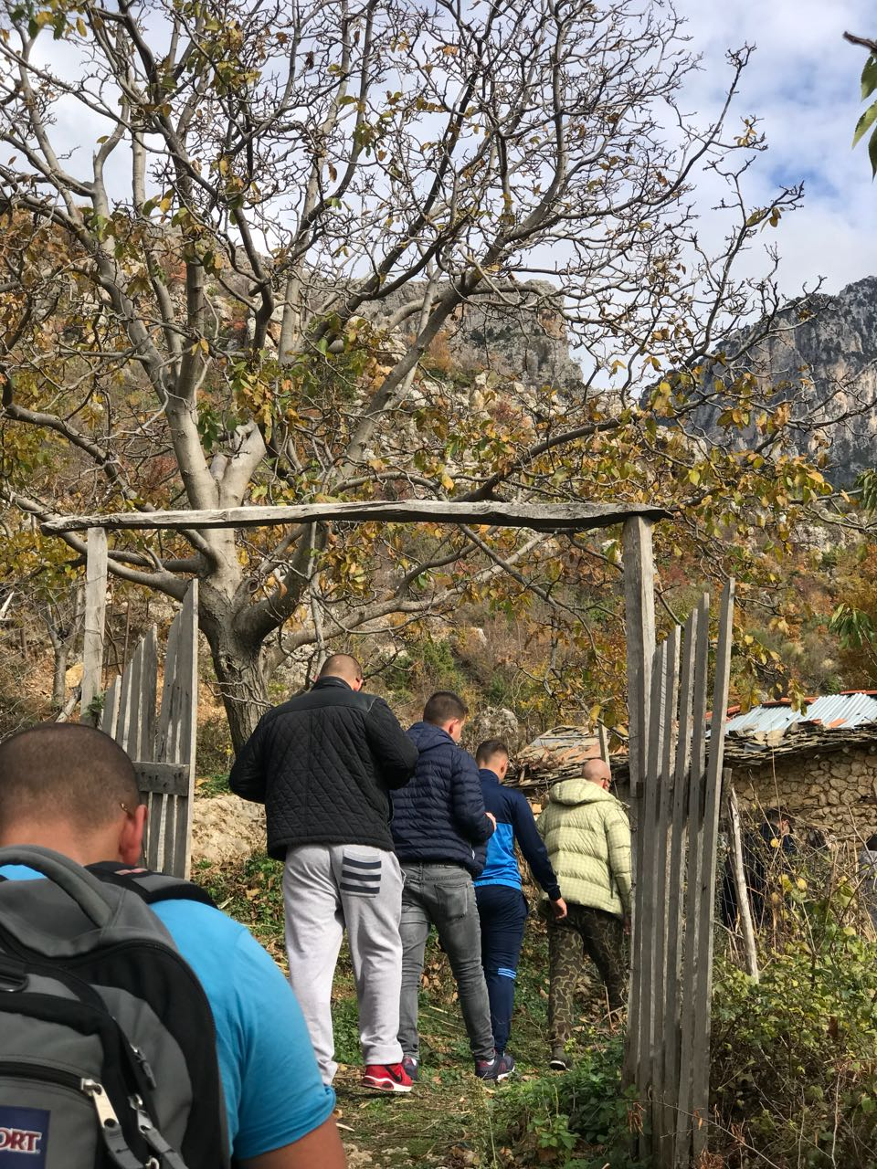
Pricing
80 Euros for 1-4 people/ 60 Euros for 5-10 people
What's Included?
- Transport as per itinerary
- English tour guide; local tour guide
- Picnic lunch with traditional food; dinner
- Park entrance fee
- Accommodation *only if you choose to stay in a local house*

What's Extra?
- Local products you wish to buy

Additional Information
This tour is meant to be an authentic journey away from modern life and thus one should not expect tourist amenities, but rather charming local hospitality in the form of eat, sleep and drink. It definitely requires an open mind! Local families are opening up their homes to us – there will be no air conditioning but you will have a fireplace if it's cold. That being said, if you have any special needs, we will do our best to accommodate. We recommend bringing comfortable clothes, hiking shoes, a jacket, a hat, your camera and mosquito repellent.

