The Historical Past of Ottoman Berat

(City Walking Tour)
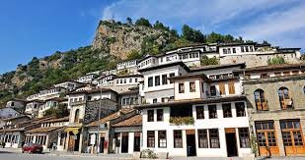
Background
In this walking tour, we will discover Berat, which is inarguably one of the most beautiful towns in Albania! Go back to the Ottoman era and see its influence in the King Mosque, the 14th-century Bektashi Mosque, Mangalem and Gorica (the old town), the Castle (and its churches) and the famous Onufri Museum. Great opportunity for photography!
Itinerary
- Start from the Islamic Centre and see the King Mosque, one of the oldest in Berat.
- Visit the famous Teqe which is close to the King Mosque.
- Head to the Gorica Quarter and walk on Gorica bridge, a monument from 1777.
- Proceed to Mangalem Quarter where we will walk into the Castle.
- Inside the castle premises, we will see three Byzantine churches from the 14th century.
- Walk towards the Ottoman part of the city and see the Akropoli, White Mosque and Red Mosque which come from the 1388 period. From here, we will get a panoramic view of the town and take a lot of photos.
- Visit the Onufri Museum, inside the castle, and learn more about this bygone era.
Pricing
15 Euros for 2-4 people, 50 Euros for groups with 5-30 people
What's Included?
Ticket for Castle, Onufri Museum and Medieval Center.
What's Extra?
Drinks, coffee, souvenirs.
Additional Information
Prices are flexible.
Let us know about any special questions or demands!

