Three Days of Rustic Life in Berat
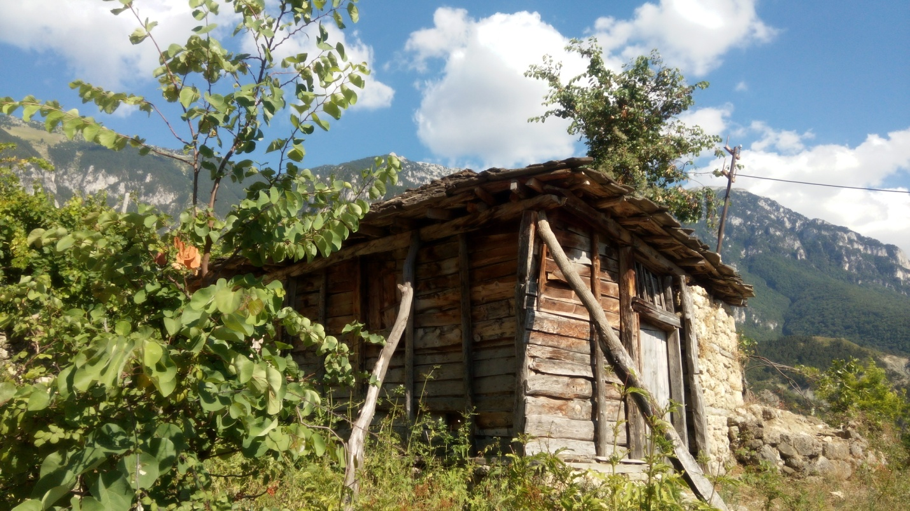
Background
This epic three-day tour from Berat to the mountainous park will take you close to a large number of mammals such as bears, wolves and birds of prey day and night. In addition to its natural elements, the park landscape is a melting pot of recreation, history and culture. We will also meet the locals who live in the national park.
Itinerary
Day 1 – Roshnik, Dardhe and Sotira Waterfall
- Our professional local driver will come to pick you up early in Berat. Prepare for an unforgettable scenic drive from there to Roshnik.
- 10-minute break in historic Roshnik, the original home of the Köprülü family, a noble family of Albanian origin who, during the Ottoman Empire, produced six grand viziers (including Kara Mustafa Pasha, who was a stepson) and high-ranking officers. The era in which these grand viziers served is known as the "Köprülü era"; we will come back to Roshnik for a wine tasting and dinner.
- Drive from Roshnik to Dardhe; 1h30 by road (depending on conditions.) During the drive, we will be surrounded by the wilderness of the National Park.
- Arrive Dardha, a 700-year-old village, rich in tradition and history. Only five families remain here - the others migrated during communist times. This is an isolated land. The locals are hospitable, kind and warm and are hard workers even thugh they are far from modernity.
- After a drive with an unforgettable view, we arrive in Dardha to meet our local guide who will take us for a 2-hour trek to an amazing waterfall called Sotira. It is the most beautiful waterfall of Albania, coming out from a cave (nobody knows where all this water comes from!) Locals believe it to be a miracle of the God of Mountains.
- We will eat a picnic lunch here. Some of you can enjoy the fresh water while the others can explore nature, caves, birds and animals.
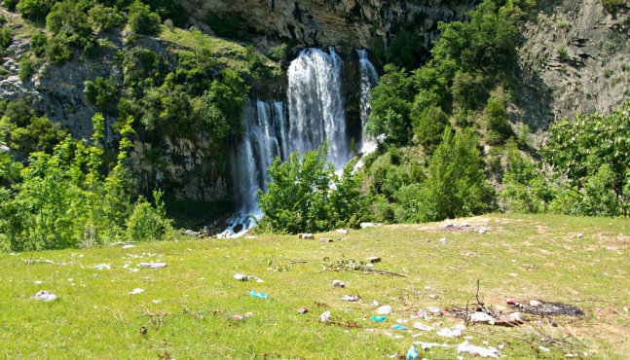
- Trek back to Dardha where we are going to sleep. Since it is going to be cold, an outside fire in the garden will be arranged while you are enjoying the stars and listening to the voice of mother nature before a peaceful sleep (maybe with some raki beforehand!)
Day 2: Explore the Beauty of Tomorr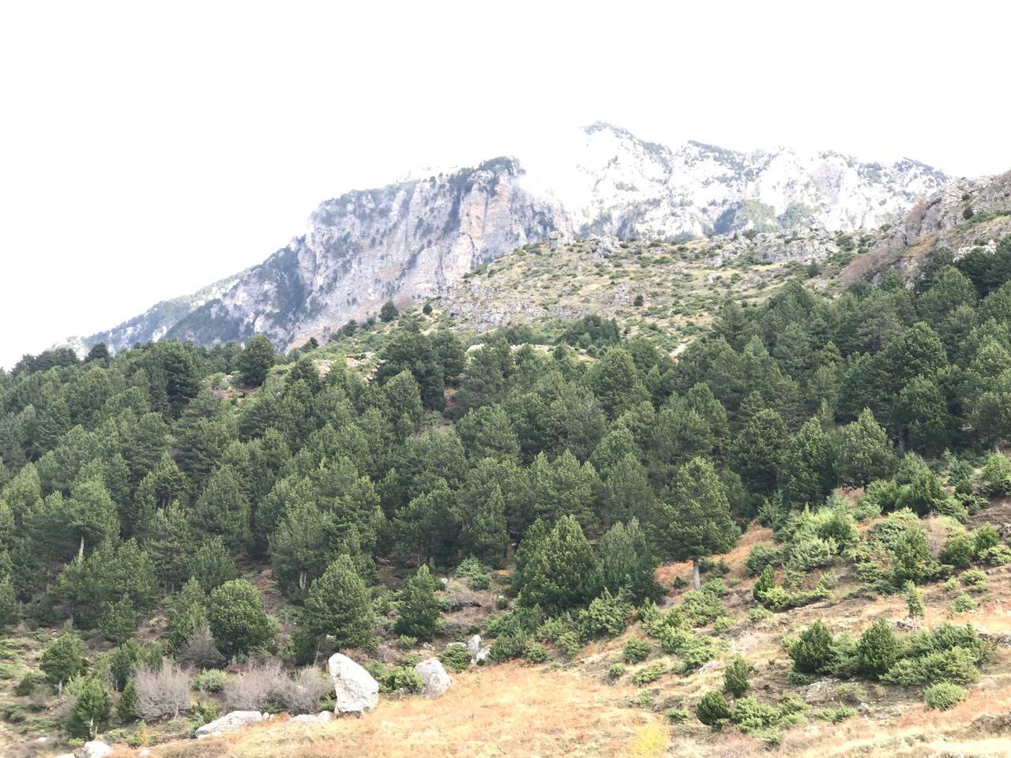
- We start early in the morning for a full day of trekking through the stunning park to reach Tomorr, an old village. Its history starts 1500 years ago, proven by the ruins of an ancient castle located on top of a huge rock.
- The trek will take 3 hours from Dardhe. We will find some old houses and traditional ways of living. Once we get there we will receive a warm welcome from the locals and enjoy a glass of raki in a Turkish café.
- The rest of the day will be set aside to explore in this unique village hosted by locals and we will hike in the Holy Mountain. We will visit the ruins of a 1200-year-old castle along with birdwatching, walking and exploring the rustic life. In a scenic hike we will be 1800m over sea level
- Traditional picnic lunch in a beautiful valley 1700 m over sea level
- Trek back to Village
- Dinner with traditional food (this area is famous for culinary delights!)
- Sleep in a local house
Day 3: Scenic Hike in Tomorr Mountain
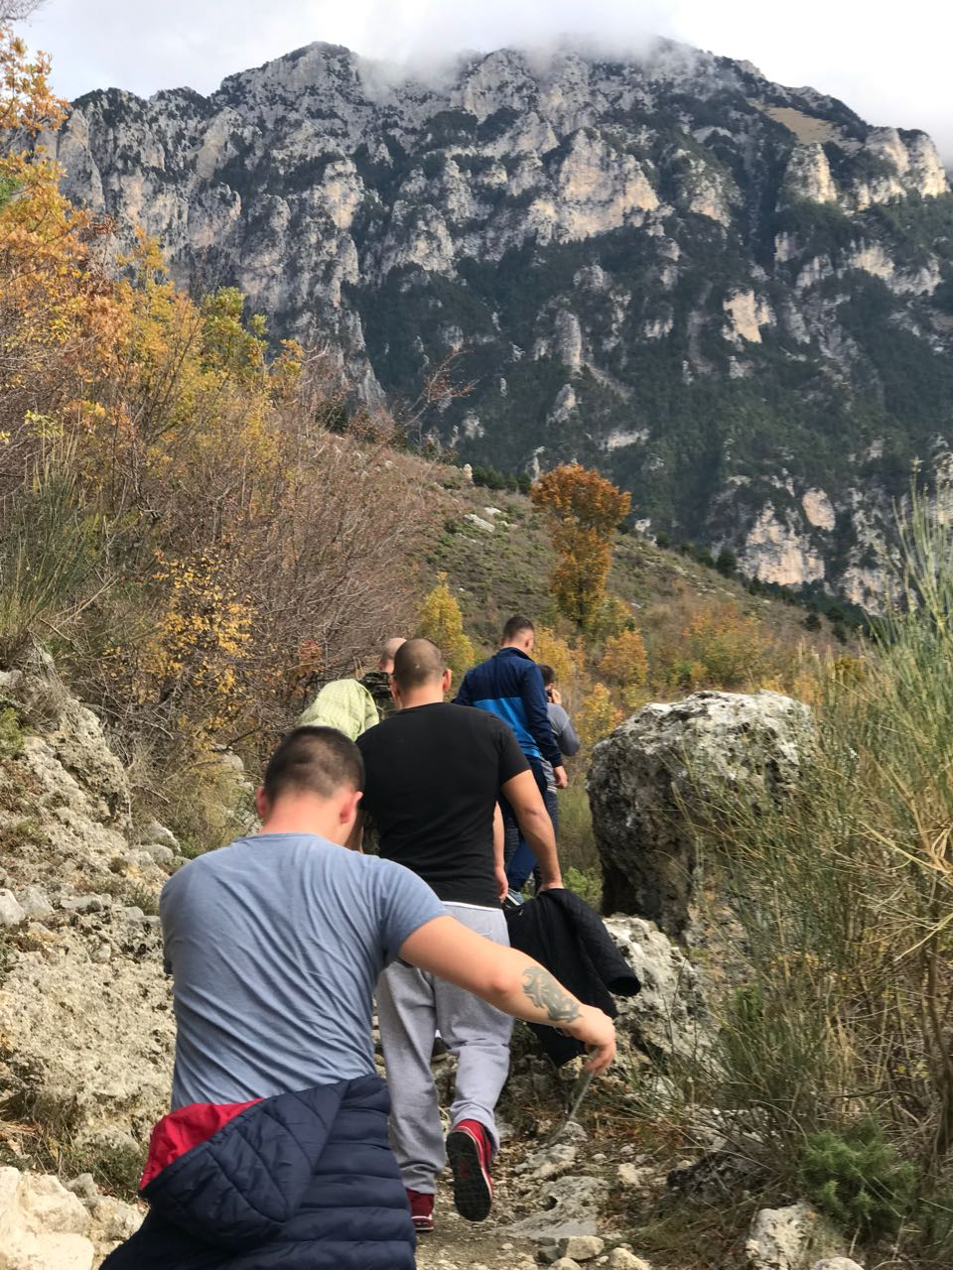

- We start early in the morning after eating breakfast outside in nature and enjoying the wind and view of the village. It will be hard to say goodbye to the locals who have been living alone for such a long time. Here you are not just a visitor but also a part of their families - expect a lot of hugs and smiles from them. As per Albanian tradition, a guest is very important and hosts will do everything to make you happy.
- Trek to Lybesha, another old village with a history that goes back more than 500 years. This trek will need more energy than the other two, but don’t worry, if someone is tired he can try to "Drive the Donkey."
- We will hike in a place called Stradom, an alpine valley located 900m over sea level. It will be a perfect day to explore, hike, birdwatch and take photos. We will eat lunch.
- After lunch it's a 1 hour walk to the car, where our driver will be waiting.
- Late in the afternoon, we go back to Berat with an unforgettable feeling in your soul.

Pricing
164 Euros for 2-4 people, 145 Euros for 5-10 people (maximum number of participants is 12)
What's Included?
- Two night's accommodation in local houses
- All transport as per itinerary with our 4x4 cars
- Two lunches, two dinners, one breakfast
- Drinks: raki, wine, water
What's Extra?
- Any local products you wish to buy
Additional Information
- Prices are flexible
- This is an authentic tour. We are going to eat and sleep in the homes of locals, who are not trained to work in tourism. This is a rustic area with simple people offering accommodation to us. It will be not air conditioned but we will have a fire place in the room
- Please let us know if you have any special questions or needs
- We suggest bringing: comfortable clothes, hiking shoes, a jacket, a hat, a camera and mosquito repellent.
- This tour could be shortened to 1 or 2 days. The goal of this tour is take you close to real Albanian tradition and to the best natural places still unknown to tourists.

