Best Hiking Trail in Berat
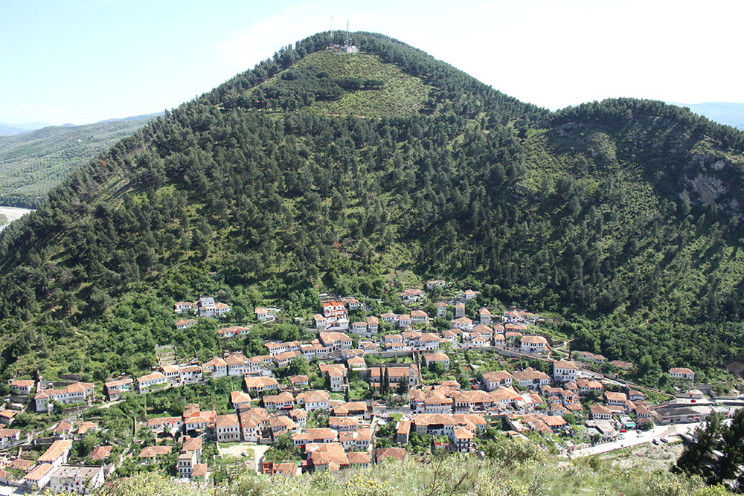
Background
Go hiking in Gorica or Partizan Mountain, which is 600m high and a part of the Berat National Park. Here you will find more than 16000 hectares of trees planted at different levels.
Itinerary

- Meet guide and begin hike.
- On the top of this mountain, you will find the old ruins of an Ilyrian Castle which dates back to the 5th century BC. The hiking path is wonderful and surrounded by hundreds of pines and bushes. While walking up this mountain, you will get a feeling of flying over Berat and you can see every corner of this wonderful city: the old houses of Mangalem, the Castle and the New Town.
- Reach the highest top of mountain.
- Back to Berat.
Pricing
18 Euros per person (*Prices are flexible )
What's Included?
- Picnic lunch: sandwiches, water
- Tour guide
- Park entrance fee
What's Extra?
Café bill in Castle Park (a bar inside the park)
Additional Info
- Duration 3-hour hike.
- Level of difficulty: medium.
- Prices are flexible.
- You need to bring: comfortable clothes, hiking shoes, a camera, sunglasses and a hat
- For any questions or special needs, please let me know.

