Hiking & Driving The Tomorri Mountain
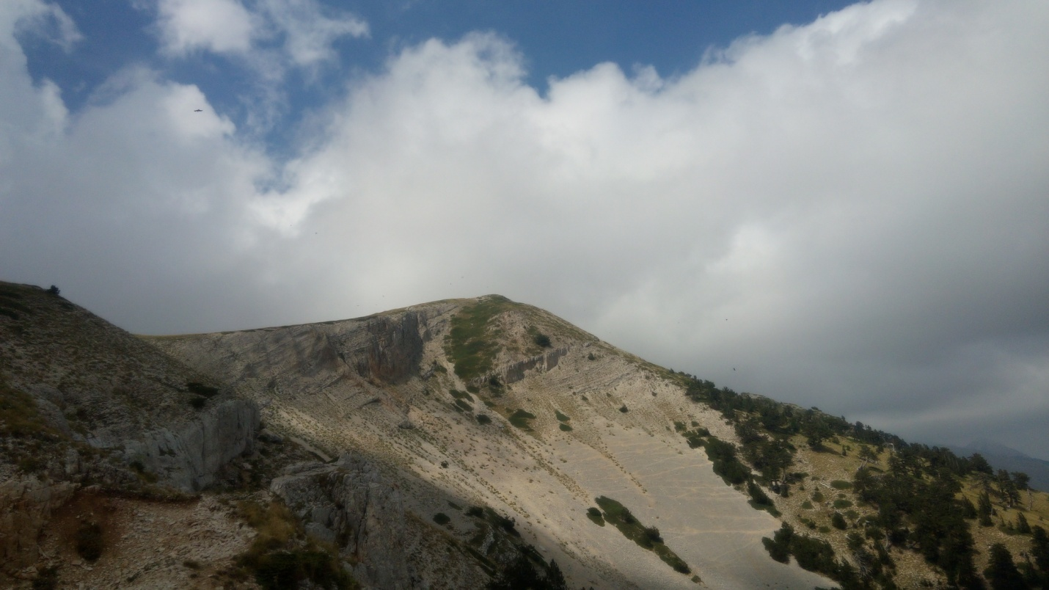
Background
Be a part of Albanian pre-history and hike Mt. Tomorri, which is the largest in Albania and also famous as the "God Mountain." While on the hike, we will meet the locals, visit a famous mosque and also visit the snow caves.
Itinerary
- We will start at 9am and after a 3-hour drive, we reach the top. The first 20km of road will be of asphalt and it will take us to the valley of the river.
- After that, the terrain will change completely and we begin the "safari" for 28 km from the bottom to top of the mountain, passing through the quaint villages where life seems not to have changed in over 100 years -you'll find old houses, horses, shops, herbs, tea on the mountain and a wonderful view of the hills that belong to other parts of Albania.
- After a 1-hour drive up the mountain, we will stop to visit the teqe - a mosque for the Bektashi sect. The teqe is located 1400m above sea level. We will learn more about this branch and also the history of its construction. This is the heart for the Bektashi from all over the world and is the reason why it's referred to as the "Holy Mountain" in Albania. The view from here is wonderful and if we are lucky, we can meet someone from here! Just beside the teqe are some monumental tombs of holy people!
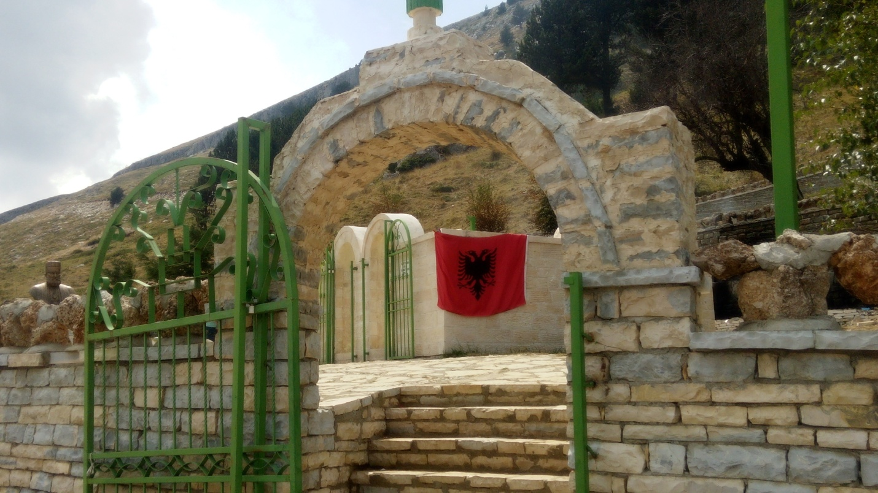

- After that, we start driving to the top, which takes about 1 hour. Here, the mountains touch the sky and clouds are all around -we will be above the clouds like the Gods of Homer!
- At the highest point, there is a monumental tomb dedicated to Abaz Ali, the main Imam of the Bektashi and relation to the Prophet Muhammad.
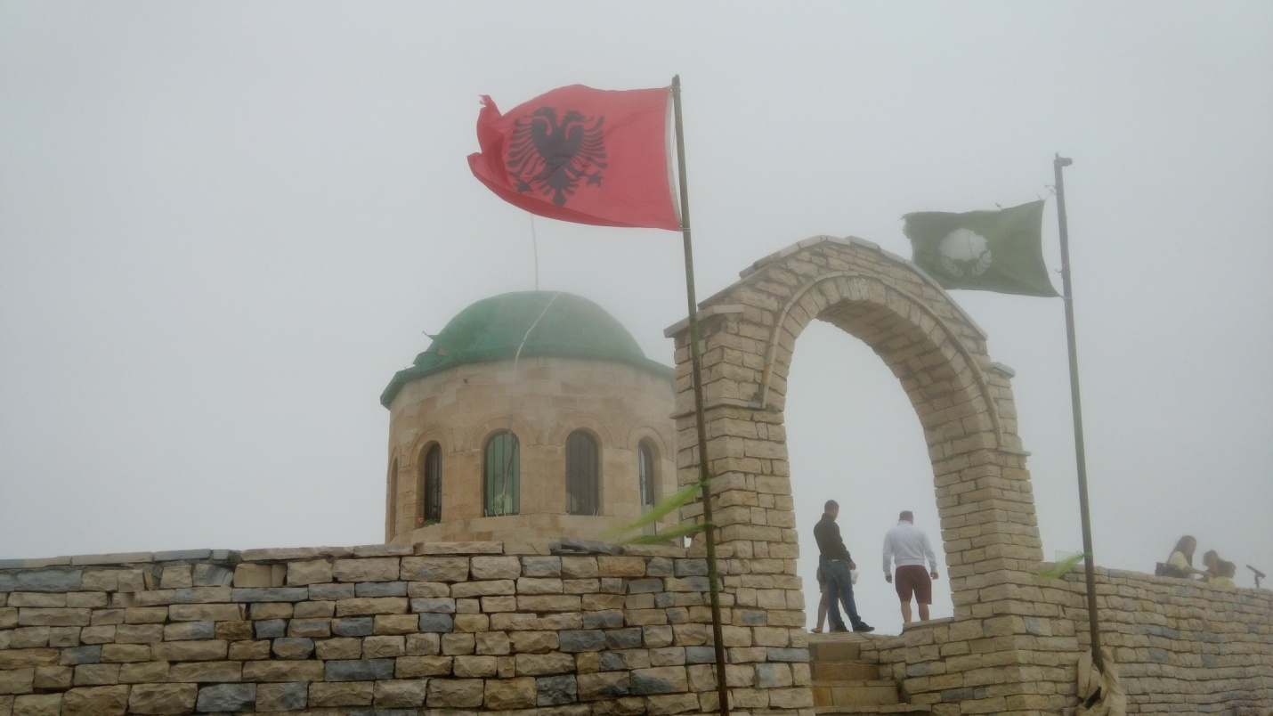
- After visiting his tomb, we will hike to the top of the Mountain, which takes one hour. We will see an amazing snow cave that is always covered with snow, even in the hottest days of August. People believe that there is some supernatural factor behind the eternal lasting of this snow. We will go inside the cave to touch it!
- Drive back to the hotel.

Pricing

90 Euros for 2-4 participants, 70 Euros for 5-10 participants

What's Included?
- Transportation as per itinerary
- Tour guide
- Professional driver
- Food (sandwiches, fruits, juices, etc.)

What's Extra?
Visit of Bogova Waterfall

Additional Information
- For groups more than 5 persons, the price will be lower.
- For 1 person price will be higher.
- Things to bring: hiking shoes, a jacket, sunglasses, a camera, water, a small backpack.
- Extra things will be not more than 10 Euros.

